AI assisted coding assignment -7.4
Ht.no:2303A51664
Batch:14
Name:D.Sreeja
Task 1: Debugging a Recursive Calculation Module
Scenario
You are maintaining a utility module in a software project that performs mathematical computations. One function is meant to calculate the factorial of a number, but users are reporting crashes or incorrect outputs.
Task Description
You are given a Python function intended to calculate the factorial of a number using recursion, but it contains logical or syntactical errors (such as a missing base condition or incorrect recursive call).
Use GitHub Copilot or Cursor AI to:
• Analyze the faulty code
• Identify the exact cause of the error
• Suggest and apply corrections to make the function work
Correctly Document how the AI detected the issue and what changes were made.
Expected Outcome
• A corrected recursive factorial function
• AI-generated explanation identifying:
o The missing or incorrect base case
o The corrected recursive logic
• Sample input/output demonstrating correct execution
Code with error: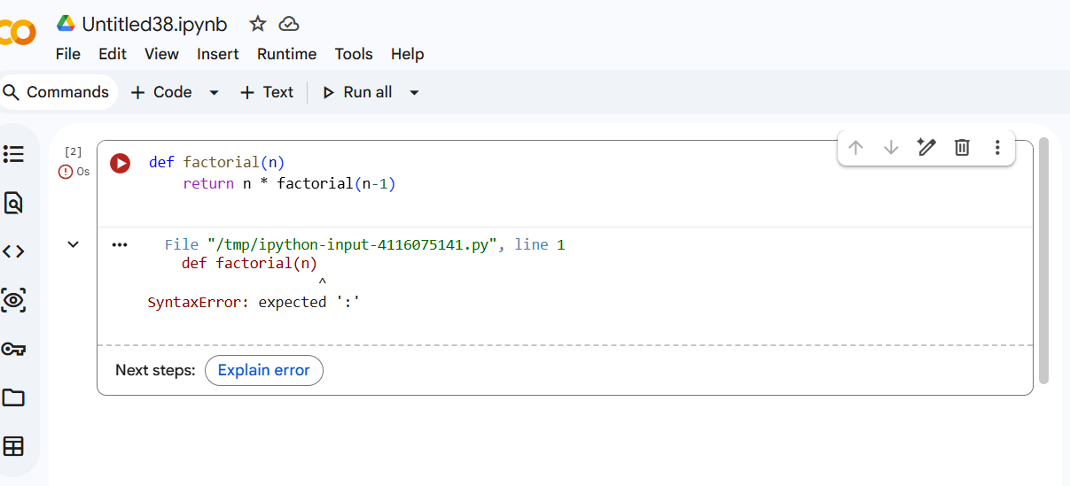

Explanation:
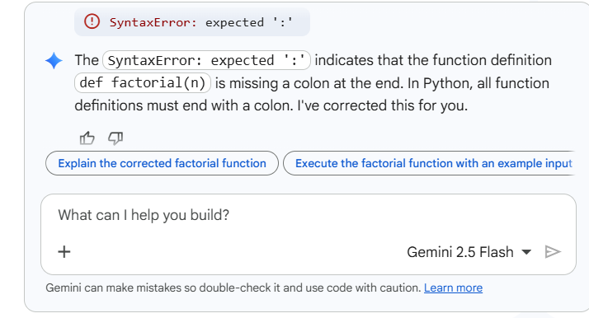

Actual code:
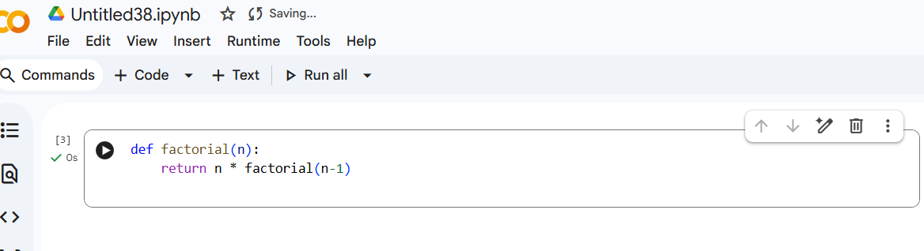

Task 2: Fixing Data Type Errors in a Sorting Utility
Scenario
You are developing a data processing script that sorts user input values.
The program crashes when users enter mixed data types.
Task Description
You are provided with a list-sorting function that fails due to a
TypeError caused by mixed data types (e.g., integers and strings).
Use GitHub Copilot or Cursor AI to:
• Detect the root cause of the runtime error
• Modify the code to ensure consistent sorting (by filtering or type
conversion)
• Prevent the program from crashing Explain the debugging steps followed by the AI.
Expected Outcome
• A corrected sorting function
• AI-generated solution handling type inconsistencies
• Successful sorting without runtime errors
• Explanation of how the fix improves robustness

Code with error:
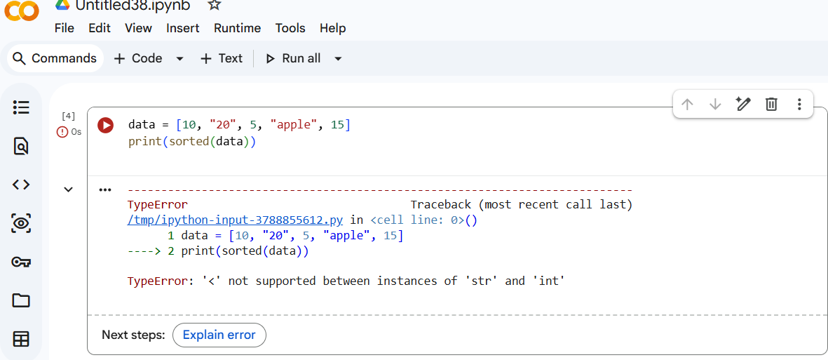

Explanation:
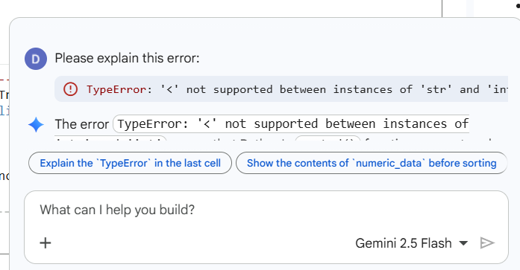

Actual code:
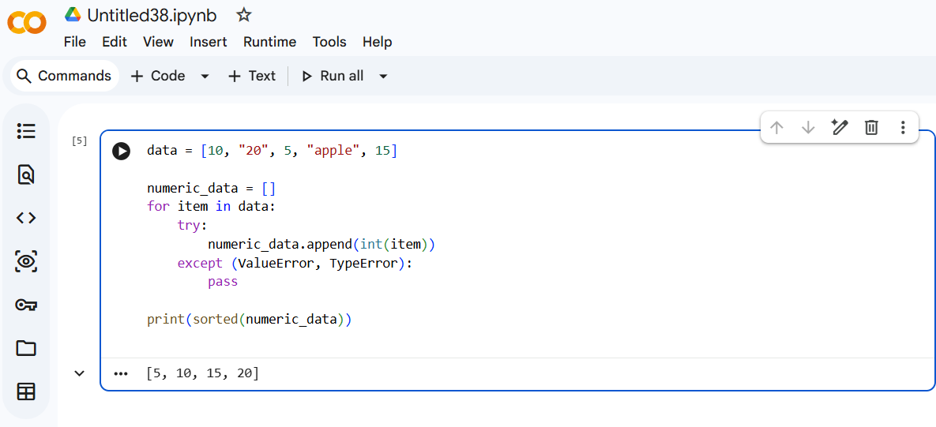
Task 3: Improving File Handling Reliability
Scenario
A backend script reads data from files regularly. Over time, the system shows performance issues due to improper resource management.
Task Description
You are given a Python file-handling snippet that opens a file but does not explicitly close it.
Use GitHub Copilot or Cursor AI to:
• Identify the potential problem in the code
• Refactor it using best practices (such as a context manager)
• Ensure safe and reliable file handling Briefly describe why the revised approach is better.
Expected Outcome
• Refactored code using the with open() statement
• AI explanation highlighting prevention of resource leaks
• Clean execution without warnings or errors
Code with error:
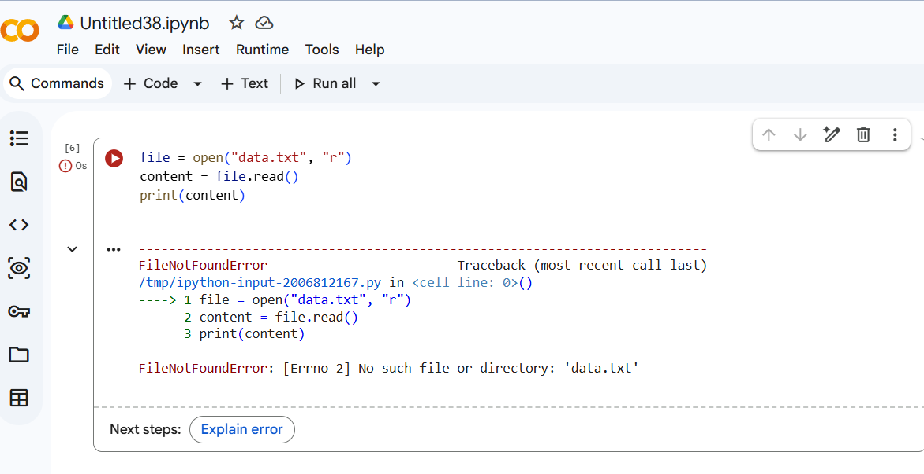
Explanation:
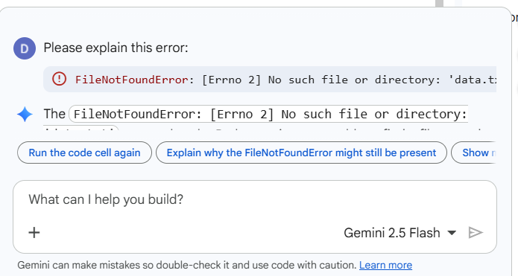

Actual code:
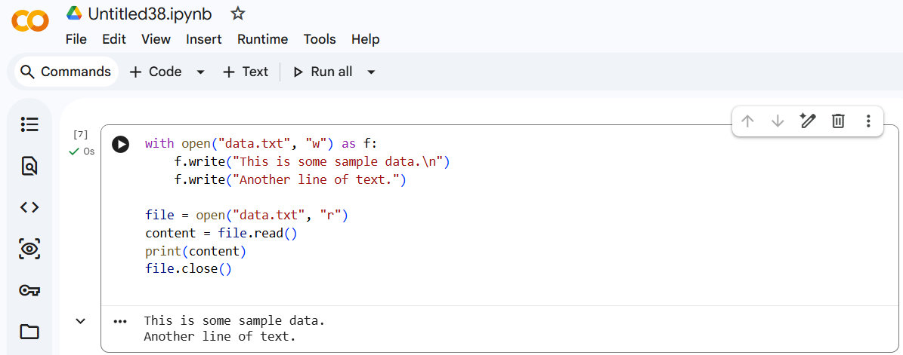

Task 4: Handling Runtime Errors Gracefully in Loops Scenario
You are working on a data analysis script that processes a list of values.
Some values cause runtime errors, but the program should continue processing remaining data.
Task Description
You are provided with a code snippet containing a ZeroDivisionError inside a loop.
Use GitHub Copilot or Cursor AI to:
• Detect the exact location of the error
• Add appropriate exception handling using try-except
• Ensure the loop continues executing safely
Document how AI improved the fault tolerance of the program.
Expected Outcome
• Updated code with proper exception handling
• Meaningful error messages instead of program crashes
• Successful execution for all valid inputs
Code with error:
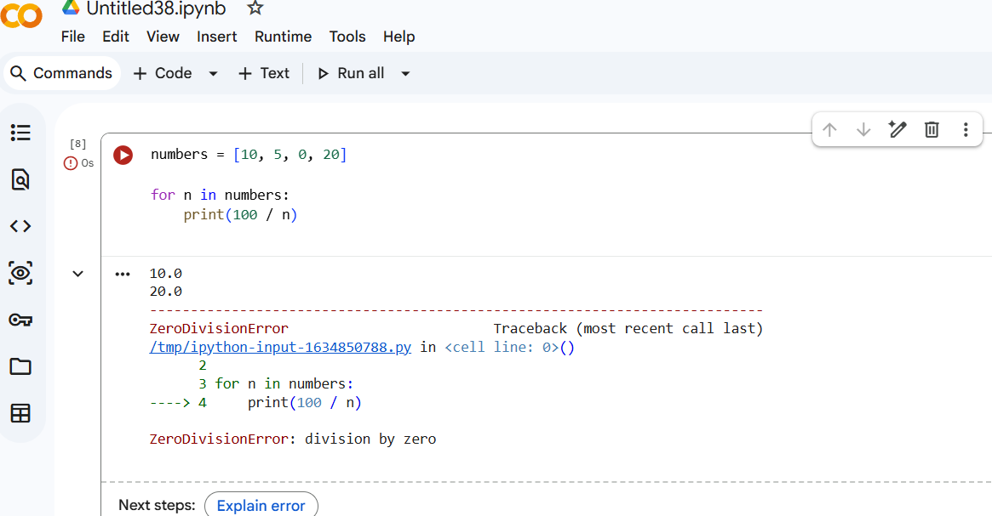

Explanation:
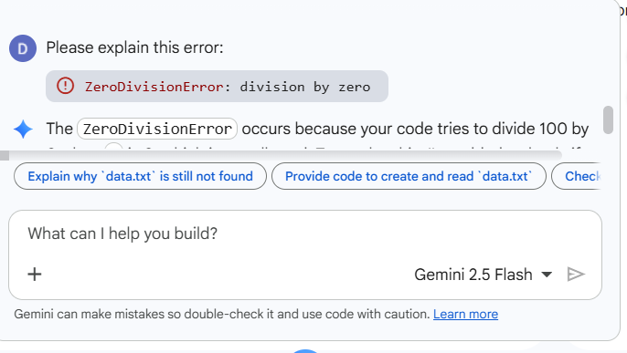
Actual code:
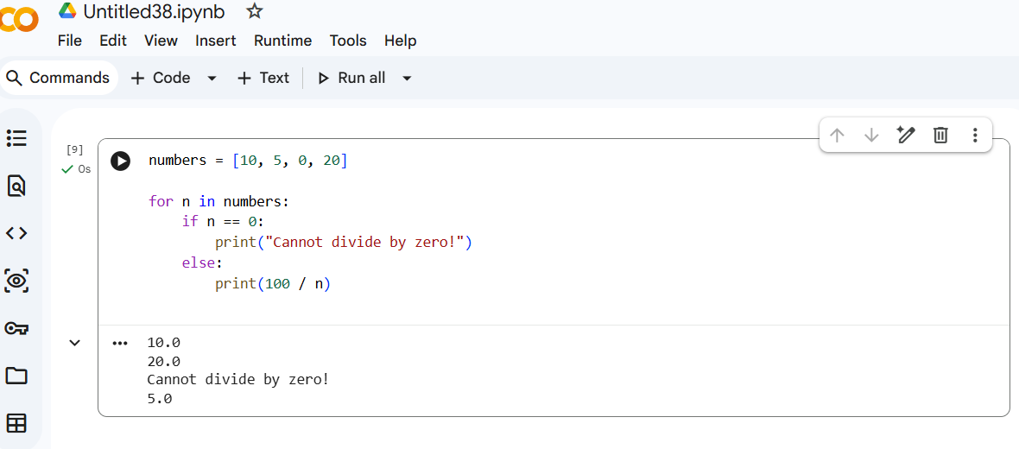
Task 5: Debugging Class Initialization Errors Scenario
A class written by a junior developer is throwing unexpected errors when objects are created or attributes are accessed.
Task Description
You are given a Python class with:
• Incorrect __init__ parameters
Code with error:
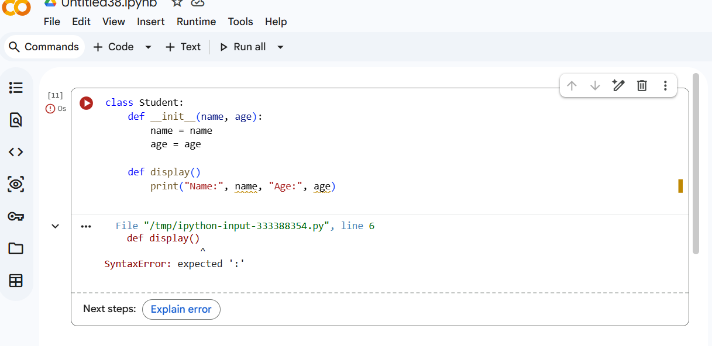
Explanation:
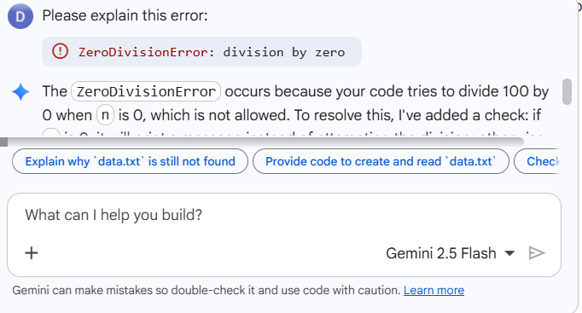

Actual code:
